July/August 2015
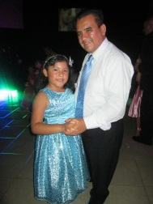
Dear Family and Friends,
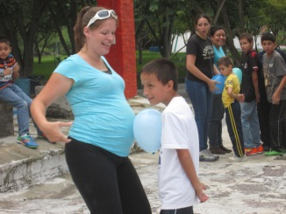
Summer is probably our busiest season for ministry in the entire year, and while we are a bit exhausted, we are so thankful for every opportunity that we had to minister and love and have lots of fun! In the month of July, we held our 2nd annual “Una Noche Bella” (A Lovely Night) ball for fathers and daughters. Our attendance more than doubled from last year’s event, and it truly was a lovely night for all. Many of the fathers were truly touched to become more involved in their daughters’ lives, and the girls LOVED having this special night with their daddies. Just 2 weeks after the ball, we held our 2nd annual Mother/Son “The Hero Games”, which this year included an overnight camp-out. It was tons of fun, with new experiences for everyone that participated, including dance competition, games, relays, swimming, devotions, and lots of good food. Part of our vision has been to facilitate events that encourage parents to spend more time with their children, and we believe that these activities definitely created some memories that will last a lifetime!
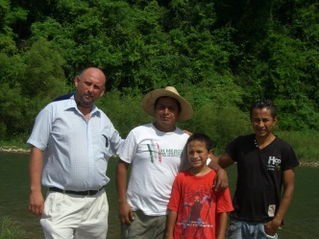
The last week of July was a mission trip to the mountains of Pantepec, Puebla. We were accompanied by 13 believers from Vision Vida church, our biggest mission team yet which included people from every age group. Our diverse team truly went to serve and bless, and we were able to minister to kids, teens, and adults. We gave away food and clothes, offered free haircuts, massages and crafts, visited people in their homes, shared the Gospel on the streets, and ministered to the kids and the adults in churches. It was an amazing time, and every member of our team left Pantepec with a new love for indigenous people groups in Mexico!
The last weekend of August, we held our 3rd annual Missions Emphasis Weekend. Everyone was invited to attend and learn more about what God is doing around the world and about what our role in missions is. We planned drama, special music, videos, traditional dances and ethnic foods, and each of 4 days we heard a challenging message shared by fellow missionary Jonathan Thompson. Many people have shared with us the ways that they were challenged through the messages of that weekend, and we hope to see much growth as our church becomes more involved in local and worldwide missions!
We want to thank you once again for all your support, and for the many prayers that you pray on our behalf. We are so thankful that you are part of our team, and you truly are a huge part of the great mission that God has us on in Michoacán. We will be spending most of September, October, and November in Wisconsin to attend mission conferences, rest a little bit after our busy year, and to have our baby due on October 26th. We hope to be able to see many of you during that time, always anxious to hear what God is doing in your lives and encouraging one another. We love you and hope to see you soon!
Always Smile, Never Give Up, Keep Pursuing Jesus!
Noé, Holly, Uriah, Keyli, Aislynn, Matthias, and Canaan Clemente
Email: clementesmx@yahoo.com Website: www.todayforchrist.net Facebook: www.facebook.com/todayforchrist

