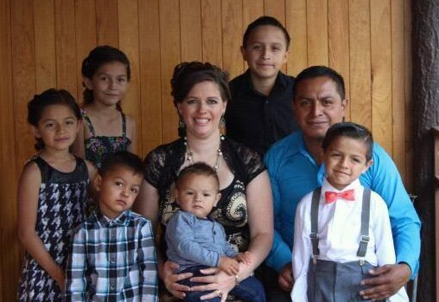
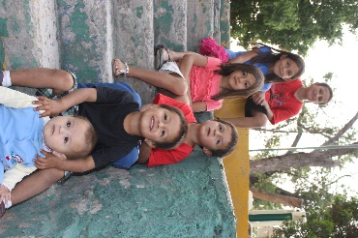
Today for Christ
Michoacán, Mexico
May/June 2017

Noe & Holly Clemente
Uriah, Keyli, Aislynn, Matthias, Canaan & Jathan

Hello Family and Friends! We hope that you all are enjoying summer and all the fun that comes with it! Our summer has been a hot one so far and we are all praying that the rains come soon. Even though it is hot and dry, God continues his work, and summer is always a productive time for ministry.
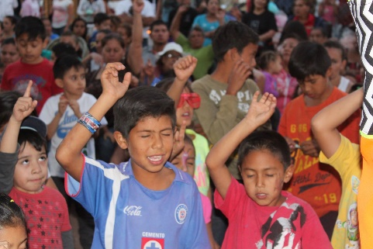
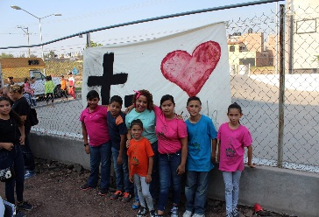
April ended with two big open-air events for the entire family in celebration of Children’s Day (April 30th). We invited Ventanita, a famous Christian clown, to minister, and he did an excellent job. Almost 600 people attended the events and many people accepted Jesus as Lord and Savior for the first time. Most of the audience participated in a very special prayer time between parents and their children, which included lots of hugs and tears.
Also at the end of April, we kicked off an AWANA club at Vision Vida church, and we are so excited about the spiritual growth that we have seen in the lives of the kids and the leaders in this short time. There are 25+ kids enrolled in the program, a great group to start off with, yet also with lots of room for growth in the future.
At the end of May, we held our third Daddy/Daughter dance at the church. It truly was A Lovely Night for the girls and their fathers, with lots of time for laughter, bonding, and sweet memories that will last a lifetime.
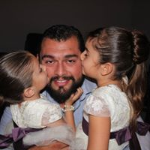
Fellow missionary David Rice shared a short message on true beauty, and the fathers coronated their daughters as princesses of the Most High in a special ceremony. Knowing the broken marriages and confusing family situations that many of the girls live with, we hope that this event was a fresh breath of joy and love into these daddy-daughter relationships!
Now we are days away from launching a fundraiser for the ministry house that we are buying. We will be posting pictures, videos, and testimonies on our Facebook page, Today for Christ, and sharing more of what our vision is for this new ministry. Please like our page and follow us to see all the updates and the specific ways that God is providing. If you feel led to give towards the house project, you can do so through PayPal (clementesmx@yahoo.com) or our home church City Church, 4909 E. Buckeye Rd, Madison, WI 53716 and include a note designating it for the Clementes’ house project.
Words are not enough to express how much we appreciate each one of you. Your prayers are vital to our family and our ministry and your financial support allows us to keep fighting the good fight here in Michoacán. We are so thankful for your love and partnership in the work that belongs to the Lord alone!
Always Smile, Never Give Up, Keep Pursuing Jesus!
Love,
The Clementes

