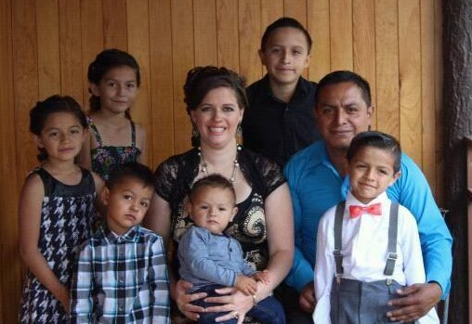
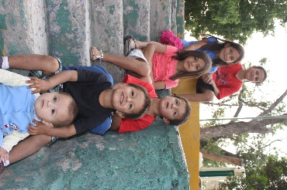
Today for Christ
Michoacán, Mexico

Noe & Holly Clemente
Uriah, Keyli, Aislynn, Matthias, Canaan & Jathan

November/December 2016

Spring is already in full swing here in Michoacán, with temperatures climbing and fans turned on all day long. These are the hottest months of the year for us, until the rains start at the end of June. It is the season for all manner of bugs and creepy-crawlies, among them spiders, scorpions, and snakes. To say the least, it’s not our favorite time of year weather-wise, but even with the hot sun beating down on our stuffy house, we are so thankful to be part of what God is doing in Mexico!
March ended with graduations from the Samaritan’s Purse discipleship program for kids. After receiving the shoebox gifts at the beginning of January for Kings’ Day, all the children were invited to attend a 12-lesson discipleship class to learn more about Jesus. Only the children who complete all 12 lessons can graduate, and at their graduation they receive a special gift and a New Testament. 11 children graduated in El Fortin, and 13 more graduated in Cumuatillo. The graduations were a happy celebration for the kids who had taken God’s Word into their hearts for so many weeks. We rented a bounce house and had food, cake, and presents to celebrate the efforts of the children and pray blessing over their lives as they share what they’ve learned with their families.
Family ministries at the church continue to grow as we seek after God and His heart. The Champions Zone Kids’ Church has been learning to be generous givers, setting aside offering money over the last few months for a needy widow in our community. The church has taken on the project of helping her fix her house, and the kids have been contributing to the project anyway that they can!
Kids’ Church now has their own worship team of kids who are learning to lead others in praise to God. We are also getting ready to dig into the Word with kids and parents as we plan to kick off our very own AWANA club next week!
On the home front, we celebrate 3 birthdays during the months of March and April. Our oldest daughter Keyli turned 10 in March, and our oldest son Uriah will turn 12 next week! It is a little amazing how fast all the kids are growing up! We are doing our best to treasure every moment with them, and are so proud of the young people they are becoming. Just days after Uriah’s birthday, we will be celebrating another year of life for Noe. We are so thankful for the father, husband, and man of God that he is. God has blessed us greatly!
We would like to thank those of you that have felt led to give to the house that we are buying for ministry. We are excited about getting this new ministry off the ground, and even though we are currently behind our goal in payments, the people who are selling the house to us are excited about our vision, and they are being very patient with us! If you feel led to give towards the house project, you can do so through Paypal or our home church City Church, 4909 E. Buckeye Rd, Madison, WI 53716 and include a note designating it for the Clementes’ house project.
As always, we are so thankful for each one of you. Your continued prayers and support are invaluable to us as a family and a ministry. Thank you for partnering with us!
Always Smile, Never Give Up, Keep Pursuing Jesus!
Love,
The Clementes

