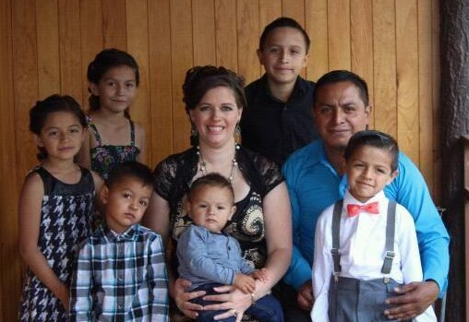
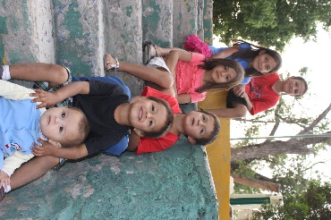

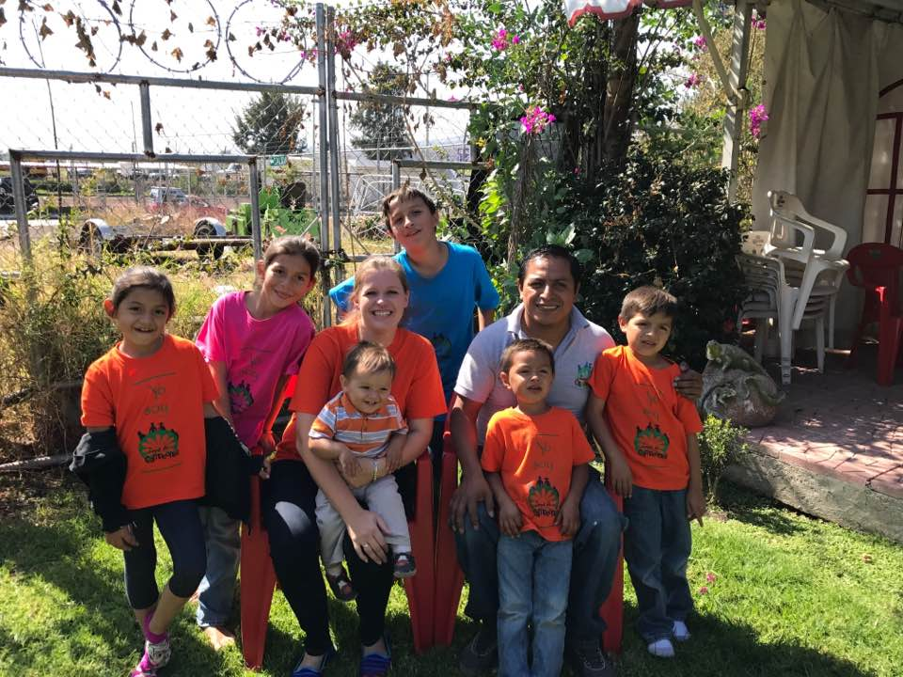
Today for Christ
Michoacán, Mexico
July/August 2017

Noe & Holly Clemente
Uriah, Keyli, Aislynn, Matthias, Canaan & Jathan

Hello Family and Friends! It’s hard to believe that summer is already at its end, and we are entering our favorite season of the year…FALL! One of the big reasons that we love fall is because we get to attend missions conferences and visit family and friends in Wisconsin. It is always a refreshing time for us after our busy summer, and we are looking forward to it this year as much as ever!
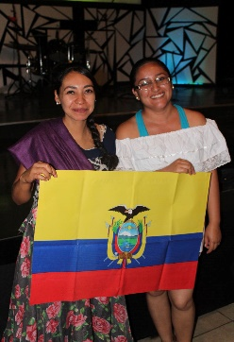
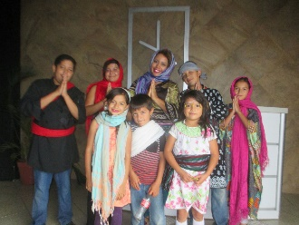
In July, we held Vacation Bible School at the church in Sahuayo. This year our theme was “To the Whole World” as part of our desire to raise up a generation of future missionaries. Each day we “traveled” to different countries to learn about the people and cultures of other nations. We talked about the importance of sharing the Good news that God saves right where we are at and around the globe. The last day of VBS was an outreach on the streets, where the kids ministered through dance, song, drama, art, and giving.
Our Sunday Bible study class for 11 to 15-year-olds at the church has really taken off. We have a dedicated, passionate team of young married couples who are teaching this group of young people, and they began seeing struggles with depression, pornography, and other temptations among the youth that they wanted to address right away. We had an overnight retreat at the church the first weekend in August to minister specifically to them and it was amazing! Afterwards, many shared testimonies of God’s love and transformational power in their lives.
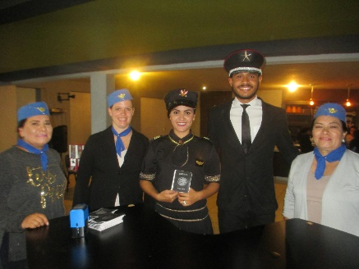
The second week of August we were privileged to have a Missions Emphasis Weekend at Vision Vida Church. Special guest missionaries, Jerry and Rachel Witt, shared about the history of missions in the Bible, and challenged the church to get more involved in the going and sending aspects of missions. The event went well, and several people have talked to us since about the possibility of being sent out as missionaries in the future. A few of them accompanied Noe on a 4-day mission trip to the mountains of Puebla last week. We give God all the glory for the ways He is working in hearts and lives around us!
During these last few months we have faced troubles on many sides, including 2 car accidents within 24 hours, a broken washing machine, a broken laptop, and car repairs. While the trials have brought an extra amount of stress to our lives, we are thankful that we are all safe and well! In the difficult times, we especially appreciate those of you who have partnered with us and our ministry. Your prayers are vital and your financial support enables us to continue the work here in Michoacán. We love and appreciate you so much! We also want to thank those who have supported the Horizon House project. With every donation, we are one step closer to opening this ministry to children and youth!
Always Smile, Never Give Up, Keep Pursuing Jesus!
Love,
The Clementes

