May/June 2014
Dear Family and Friends,
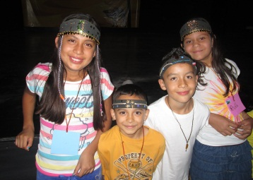
God is so good, and His mercies are new every morning. We are honored to be part of the work He is doing in Michoacán. What a great God we serve!
Ancient Egypt Kids’ Camp was amazing this year. 40 children attended, and we all had so much fun learning to not forget the great things God has done for us. Although camps are filled with fun and games, we also had some great times of ministry with the kids, praying with them for some big needs. It was so special to see them responding in worship and talking with God as a friend and Father.
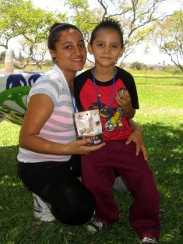
On May 17th we had our first Mother/ Son event called “The Hero Games”. It was designed to give moms a chance to hang out with their sons, affirm their competitive, heroic spirits, and have fun together. Noé shared with us a short message from Wild at Heart by John Eldredge, which was both encouraging and challenging. It was a day full of competitions and prizes which ended with hours of swimming at a local pool. All the moms and boy who attended enjoyed the event and are already asking when we are going to do it again!
The first weekend in June, we held our 2nd annual missions emphasis weekend at the church in Sahuayo. The theme was Open Our Eyes and our goal was to motivate the local Mexican church to become more involved in local and international mission. Our good friends and fellow missionaries Bill Valley and David Rice shared challenging messages with the church body, reminding us that Jesus called us all to be part of the Great Commission. As we highlighted the nations of Belize, Ecuador and India, we had times of worship in different languages, traditional dances from each country, skits portraying cultural problems that missionaries are working to combat, and authentic foods to try at the end of each evening. We hope this event brings an awareness of the need in other nations, a call to pray for nations around the globe, and an excitement to give of resources and time to reach the unreached and to love without borders.
On a personal note, Uriah and Noé both celebrated birthdays at the end of April. We are thankful for their lives and the blessing they are not only to our family, but to everyone they come in contact with. Last month, we received the news that we are once again expecting a baby! We are very excited that God has decided to bless us yet again with a child, and we can’t wait to meet his newest little one who is due in January of 2015. Less than 2 months to go for our mission trip to Belize. We are excited to be leading a team of Mexican believers to serve and learn alongside missionaries Craig and Jadine Fritzler. When we started planning for the trip, it seemed that it would be impossible to save the 3,000 dollars we needed to go as a family, but God has provided every need, and we are now just 500 dollars short of our goal! If anyone would like to help send us to Belize, please visit our website and make a donation through Paypal, or send a check to City Church with a note saying it’s for the Clementes trip to Belize! From the bottom of our hearts, we thank each one of your for your ongoing prayers and support. Thank you for partnering with us to reach Michoacán!
Always Smile, Never Give Up, Keep Pursuing Jesus!
Noé, Holly, Uriah, Keyli, Aislynn, Matthias, and Canaan Clemente
Email: clementesmx@yahoo.com NEW Website: www.hswinburn9.wix.com/whatever
Facebook: www.facebook.com/todayforchrist

